Project 3.1. (Short explanation)
The steps:
- The meaning of Apriori : is to eliminate some of the candidate item set without counting their support values.
- If an item set is frequent, then all of its subset must also be frequent.
Here in the association rules we use ;
We can predict the arrtibute and the class,
3. The converge:
Is the number of a association rule is the number of instances for which it predicts correctly.
- the accuracy:
Which the confidence how often the rule is frequently item set
- A priori algorithm: it starts with a minimum support {converge}
Of 100% of the data items and decreases in steps of 5% until there are 10 rules with the required minimum confidence of 0.9 or until the support reach 10%.
To rank rules.
  - Confidence, which is converting by the consequent, also called accuracy.
  - Lift which is determined by dividing the confidence by the support ( called coverage.
  - leverage ,were statistically independent
  - Conviction.
- As result: see file (1): see figure (1).

Apriori:
=======

Minimum support: 0.1 (1 instances)
Minimum metric <confidence>: 0.9
Number of cycles performed: 18

Generated sets of large item sets:

Size of set of large item sets L(1): 7

Size of set of large item sets L(2): 15

Size of set of large item sets L(3): 8

Best rules found:

1. outlook=overcast 4 ==> play=yes 4 conf:(1)
2. outlook=rainy play=yes 3 ==> windy=FALSE 3 conf:(1)
3. outlook=rainy windy=FALSE 3 ==> play=yes 3 conf:(1)
4. windy=FALSE play=no 2 ==> outlook=sunny 2 conf:(1)
5. outlook=overcast windy=TRUE 2 ==> play=yes 2 conf:(1)
6. outlook=overcast windy=FALSE 2 ==> play=yes 2 conf:(1)
7. outlook=rainy play=no 2 ==> windy=TRUE 2 conf:(1)
8. outlook=rainy windy=TRUE 2 ==> play=no 2 conf:(1)
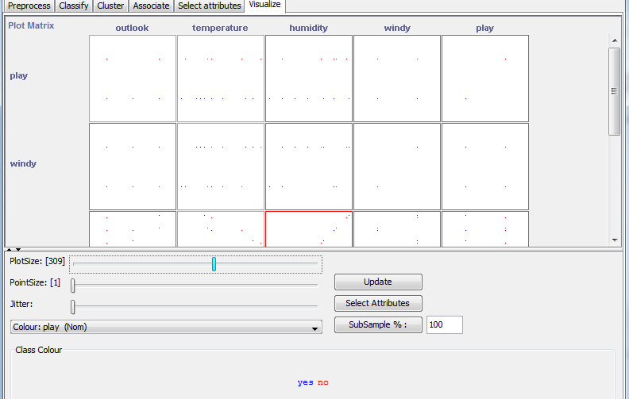
Figure (1)
- PredictiveApriori:
It is combines confidence and support into a single measure of predictive accuracy.
Here in this algorithm increases successively the support threshold because the value of predictive accuracy depends on it.
- As result:
PredictiveApriori
===================

Best rules found:

1. outlook=overcast 4 ==> play=yes 4 acc:(0.89255)
2. outlook=rainy windy=FALSE 3 ==> play=yes 3 acc:(0.83487)
3. outlook=rainy play=yes 3 ==> windy=FALSE 3 acc:(0.83487)
4. outlook=rainy windy=TRUE 2 ==> play=no 2 acc:(0.75023)
5. outlook=rainy play=no 2 ==> windy=TRUE 2 acc:(0.75023)
6. windy=FALSE play=no 2 ==> outlook=sunny 2 acc:(0.75023)
7. windy=FALSE 8 ==> play=yes 6 acc:(0.58605)
8. play=yes 9 ==> windy=FALSE 6 acc:(0.55876)
9. outlook=sunny 5 ==> windy=FALSE 3 acc:(0.49768)
10. outlook=sunny 5 ==> play=no 3 acc:(0.49768)
11. outlook=rainy 5 ==> windy=FALSE play=yes 3 acc:(0.49768)
12. play=no 5 ==> outlook=sunny 3 acc:(0.49768)
13. play=no 5 ==> windy=TRUE 3 acc:(0.49768)
14. windy=TRUE play=yes 3 ==> outlook=overcast 2 acc:(0.49602)
15. windy=TRUE play=no 3 ==> outlook=rainy 2 acc:(0.49602)
16. windy=TRUE 6 ==> play=yes 3 acc:(0.46149)
17. windy=TRUE 6 ==> play=no 3 acc:(0.46149)
18. windy=FALSE play=yes 6 ==> outlook=rainy 3 acc:(0.46149)
19. outlook=overcast 4 ==> windy=FALSE play=yes 2 acc:(0.44955)
20. outlook=overcast 4 ==> windy=TRUE play=yes 2 acc:(0.44955)
21. play=yes 9 ==> outlook=overcast 4 acc:(0.43931)
22. outlook=sunny 5 ==> windy=TRUE 2 acc:(0.41025)
23. outlook=sunny 5 ==> play=yes 2 acc:(0.41025)
24. outlook=sunny 5 ==> windy=FALSE play=no 2 acc:(0.41025)
25. outlook=rainy 5 ==> windy=TRUE play=no 2 acc:(0.41025)
26. play=no 5 ==> outlook=sunny windy=FALSE 2 acc:(0.41025)
27. play=no 5 ==> outlook=rainy windy=TRUE 2 acc:(0.41025)
28. windy=FALSE 8 ==> outlook=sunny 3 acc:(0.39591)
29. windy=FALSE 8 ==> outlook=rainy play=yes 3 acc:(0.39591)
30. windy=TRUE 6 ==> outlook=sunny 2 acc:(0.3746)
31. windy=TRUE 6 ==> outlook=overcast play=yes 2 acc:(0.3746)
32. windy=TRUE 6 ==> outlook=rainy play=no 2 acc:(0.3746)
33. play=yes 9 ==> windy=TRUE 3 acc:(0.36747)
34. play=yes 9 ==> outlook=rainy windy=FALSE 3 acc:(0.36747)
35. windy=FALSE 8 ==> outlook=sunny play=no 2 acc:(0.31538)
36. windy=FALSE 8 ==> outlook=overcast play=yes 2 acc:(0.31538)
37. play=yes 9 ==> outlook=sunny 2 acc:(0.29139)
38. play=yes 9 ==> outlook=overcast windy=TRUE 2 acc:(0.29139)
39. play=yes 9 ==> outlook=overcast windy=FALSE 2 acc:(0.29139)

- Tertius algorithm:
It finds rules according to a confirmation measure, it seeking rules with multiple conditions in the consequent like Apriori but differing in that ,these conditions are OR together not AND . it can be set to find rules that predict a single condition or predetermined attribute.

- As result:
The rules:
Tertius
=======

1. /* 0.555556 0.000000 */ play = no ==> windy = TRUE or outlook = sunny
2. /* 0.469374 0.000000 */ outlook = overcast ==> play = yes
3. /* 0.467119 0.357143 */ play = yes ==> outlook = overcast
4. /* 0.458333 0.071429 */ play = yes ==> windy = FALSE or outlook = overcast
5. /* 0.434814 0.000000 */ windy = TRUE and outlook = rainy ==> play = no
6. /* 0.434814 0.000000 */ play = yes and outlook = rainy ==> windy = FALSE
7. /* 0.400000 0.000000 */ play = no and outlook = rainy ==> windy = TRUE
8. /* 0.347543 0.142857 */ outlook = sunny ==> play = no
9. /* 0.347543 0.142857 */ play = no ==> outlook = sunny
10. /* 0.342751 0.071429 */ outlook = sunny ==> windy = TRUE or play = no
11. /* 0.287295 0.142857 */ windy = TRUE ==> play = no or outlook = sunny
12. /* 0.284177 0.071429 */ windy = TRUE and play = no ==> outlook = rainy

Number of hypotheses considered: 118
Number of hypotheses explored: 107
- Using HotSpot targeting temperature:
The steps :
- Choose only the attribute of the temperature from preprocess.
- then select the HotSpot from the associate selection.
The result is: see file (3).
=== Run information ===

Scheme: weka.associations.HotSpot -c last -V first -S 0.33 -M 2 -I 0.01
Relation: weather-weka.filters.unsupervised.attribute.Remove-R1,3-5
Instances: 14
Attributes: 1
temperature
=== Associator model (full training set) ===

Hot Spot
========
Total population: 14 instances
Target attribute: temperature
Minimum segment size: 5 instances (33% of total population)
Maximum branching factor: 2
Minimum improvement in target: 1%
temperature (73.5714)
- if I choose HotSpot for only the temperature and I choose all filters the result is:
Associator Model

Hot Spot
========
Total population: 14 instances
Target attribute: temperature
Minimum segment size: 5 instances (33% of total population)
Maximum branching factor: 2
Minimum improvement in target: 1%

Temperature (73.5714), see figure (1).
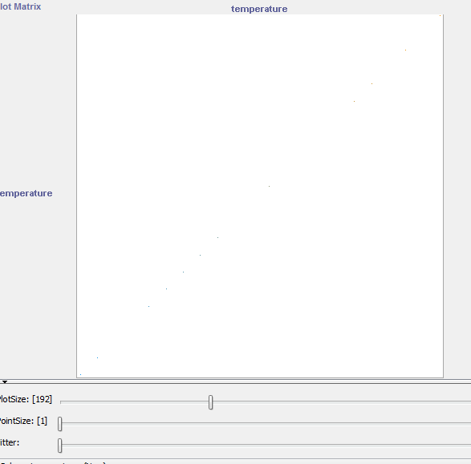
Figure (1).
- if applay the Hot Spot for all data set the result is:
Associator Model
Hot Spot
========
Total population: 14 instances
Target attribute: play
Target value: yes [value count in total population: 9 instances (64.29%)]
Minimum value count for segments: 5 instances (33% of total population)
Maximum branching factor: 2
Minimum improvement in target: 1%

play=yes (64.29% [9/14])
humidity <= 80 (85.71% [6/7])
| temperature > 65 (100% [5/5])
windy = FALSE (75% [6/8])
| temperature <= 83 (85.71% [6/7])
| | humidity <= 86 (100% [5/5])
| humidity <= 86 (83.33% [5/6])
Here the percentage is greater than the in case (3). See figure (2).

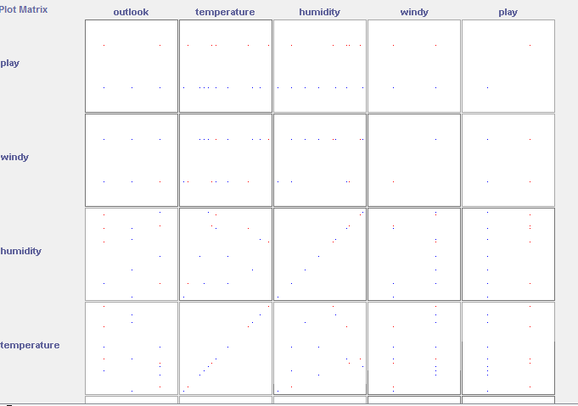
Figure (2).

